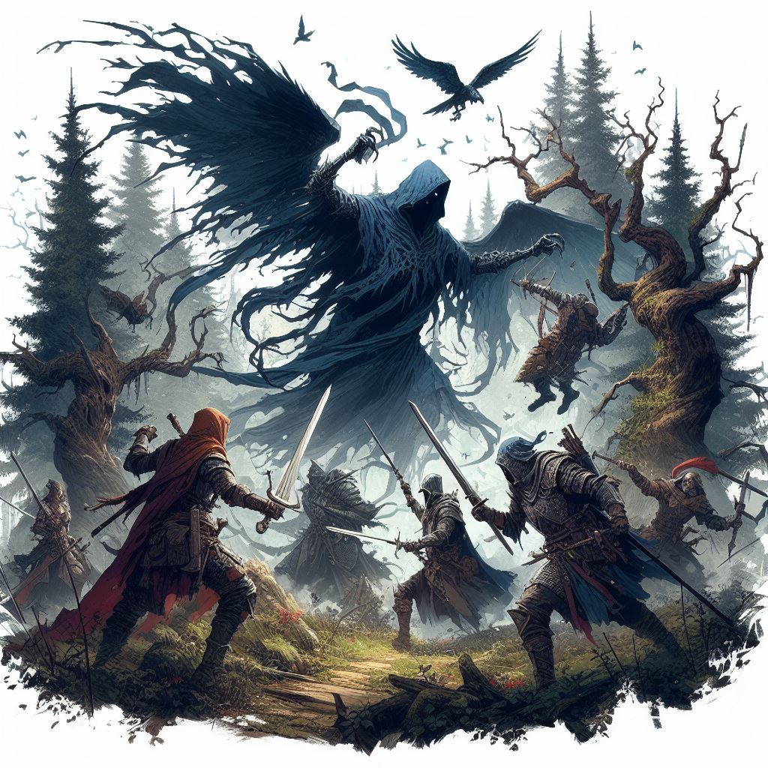







# E:\Work\GitHub\Call of Heroes Design\StarterAdventure\UI\Title Underline.pngTitle UnderlineIntroduction

Welcome, Game Master! This book is for your eyes only. It contains the QuestGuard starter campaign Whispervale with instructions on how to play and organize this story for your players.

If you are not a Game Master, close this book immediately.

## Who Is This For

This book is intended for beginner Game Master and players who have never played QuestGuard. It was made to be as easy as possible to run.

If you have never been a Game Master, now is your chance.

## What To Expect

Whispervale follows a group of 3 to 5 players, on an adventure that will last (on estimate) 5 to 10 game sessions, depending on the group’s pace and duration of sessions.

As a Game Master, you are **not required to read this book in advance**. Whispervale was made to be **read at a glance** - it requires minimal preparation. However, please read everything up until Chapter 1

before you begin, to learn how to use this book. Once you get to Chapter 1, simply let the book guide you.

The book contains many read-aloud sections, and flows top-to-bottom, left-to-right and will guide you through everything you need to say and do.

This campaign also teaches the players the basic rules of QuestGuard in the first sessions.

It also teaches you, the Game Master, the rules for QuestGuard from a Game Master’s perspective.

## Your Responsibility

As a Game Master, you will be the narrator and referee of the game. You present situations, and players will try to do things in those situations. A lot of the times, a **Check** is required (a roll of a die) to determine if the player succeeds in their action.

You will be responsible for reading passages out loud for your players, roleplaying as non-player characters (e.g. speaking in the voice of another character or conveying what they are saying), controlling the monsters in fights (e.g. rolling dice for them) and, usually, making sure every player gets their time in the spotlight and is having a good time.

# E:\Work\GitHub\Call of Heroes Design\StarterAdventure\UI\Title Underline.pngTitle UnderlineHow to Read It

This section explains how to read the book and interpret various elements.

## Read-Alouds

When you encounter text with a tan background like this one, read it out loud for the players.



*This is some sample text.*

*It’s just an example.*

*Whenever you see this in the section you’re in,*

*read it out loud.*

There will be a lot of these and they will narrate not just story elements, but also rules.

As a Game Master, **a lot of the information you have is from read-alouds**. These read-alouds will serve as information for both you and the players.

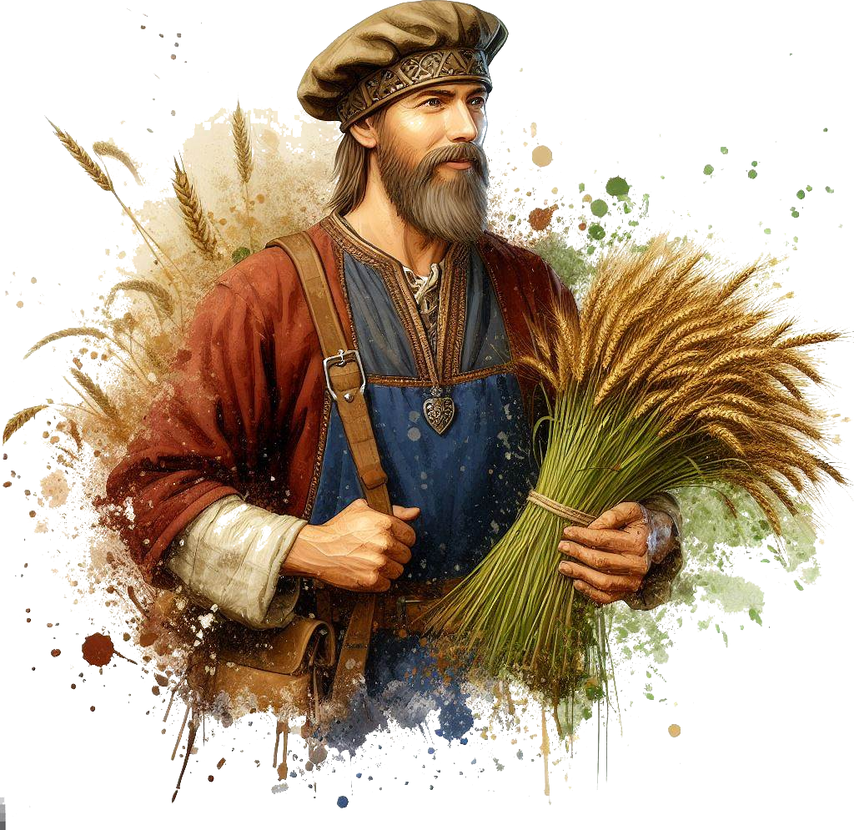

## NPC Replies

In some sections, NPC’s (non-player characters from the story) will have potential replies to say. Here is an example for a random peasant players encounter:



***“****Welcome to our village, adventurers!”*

***“****You look hungry. Head over to the tavern, they*

*serve good food!”*

***…****I did see* ***a strange man******in the******woods*** *last night!*

*…No, I never* ***stole*** *anything in my life! [lie,*

*he stole coins from the church donation box]*

You will see read-alouds with NPC replies.

The first few lines, in quotes, are dialogue lines meant to be **said directly** by the NPC (e.g. casually mentioning them in a conversation). For example, say the first dialogue line, wait for the players’ response, and if you see fit, say the next dialogue line. Rinse and repeat.

Lines starting with **…** are meant to be **only answers to questions** players ask, and should not be given without being asked specifically about the subject.

**Bold** phrases or words are emphasized to easily come into your view in case players ask about it.

If an NPC has no dialogue lines about a subject, then they don’t know about it.

## NPC’s - When In Doubt…

When in doubt of what an NPC would say, resort to them saying *“I don’t know”*. Perhaps if the NPC has authority over the players, they might say *“That doesn’t matter”*.

Don’t worry - you will get good information on NPC’s that is easily readable at a glance, without requiring preparation.

Feel free to paraphrase NPC dialogue lines.

If you don’t understand what an NPC’s dialogue lines, don’t worry - the players don’t understand either. Just go with it.

# E:\Work\GitHub\Call of Heroes Design\StarterAdventure\UI\Title Underline.pngTitle UnderlineLocations & Sections

The book’s chapters function as Locations.

Each “chapter” is a separate Location that contains read-alouds, artwork, scenarios, etc.

Here is an example:

# E:\Work\GitHub\Call of Heroes Design\StarterAdventure\UI\Title Underline.pngTitle UnderlineThe Windmill



*As you ascend the winding cobblestone path, you*

*approach a decrepit fence. Pushing through the*

*rotting wood, you arrive at the entrance of an old*

*wooden windmill, now reclaimed by nature,*

*overgrown with vegetation. The air carries a*

*musty scent, tinged with the earthly smell of*

*decaying wood, hinting that has been standing for*

*centuries, untouched by human hands in many*

*decades.*

## If Sections…

Some sections are titled “If…”.

Only read these sections if the title applies. If not, skip them and continue.

For example:

## If There Are 5 Players…

*As* ***[player 5]*** *enters the windmill, the floorboards*

*crack open and* ***[player 5]*** *falls through*

*into a stone basement.*

## Returning to Locations

If players return to a location or NPC, don’t repeat the same read-alouds or dialogue lines (unless they specifically ask for it).

## Running Combats

When running combats, try to spread the enemies as evenly as possible on the players (e.g. if you have 4 enemies and 4 players, each enemy should attack a different player). Dying in the first round is no fun!

…unless players want to spread the damage differently (e.g. if the knight wants to front-line and take the damage instead of the mage in the back).

To find the **stats of a monster**, check the **Appendix**.

## Random Encounters

There exists a list of random possible encounters players can have while exploring the forest.

Event locations in the random encounters can be placed anywhere on the map.

If they are (almost) full Health and Mana, give them a **combat encounter**. If not, give them a **non-combat encounter**. Pick randomly or whichever sounds interesting.

Some encounters can be resolved through either combat or roleplay and negotiation.

All random encounters are connected to the main story.

If players ask for extra work, invent a mission and have an NPC send them to do a specific random encounter (e.g. a guard sends them to investigate smoke coming from the forest - this would the the **Tent & Campfire** encounter). Award missions with between 50 and 250 gold, depending on how hard you think it will be for them.

All random encounters are listed at the **beginning of the adventure**.

Every random encounter is detailed as a separate **Location** **at the end of the book**.

## Props

The campaign contains paper props, such as a map, secret letters, etc. Only give these out when instructed by the book. Keep them secret until

# E:\Work\GitHub\Call of Heroes Design\StarterAdventure\UI\Title Underline.pngTitle UnderlineStory Breakdown

The story begins as soon as all the players are ready and have their characters finished.

This adventure follows the player characters exploring the gloomy town of Whispervale and fighting the forces of the vampire lord Sedrik, while struggling to rid themselves of a strange curse.

It starts with the player characters escorting a priest to Whispervale. They are soon ambushed by a group of black ghosts, which they will have to defeat. Regardless of their victory, the ghosts curse the players.

The players will eventually get to Whispervale

and the story will unfold, revealing the secrets of lord Sedrik and of the inhabitants of Whispervale.

When you want to present the idea of

Whispervale to your players, read the following

out loud:



*Whispervale: a town at the edge of civilization*

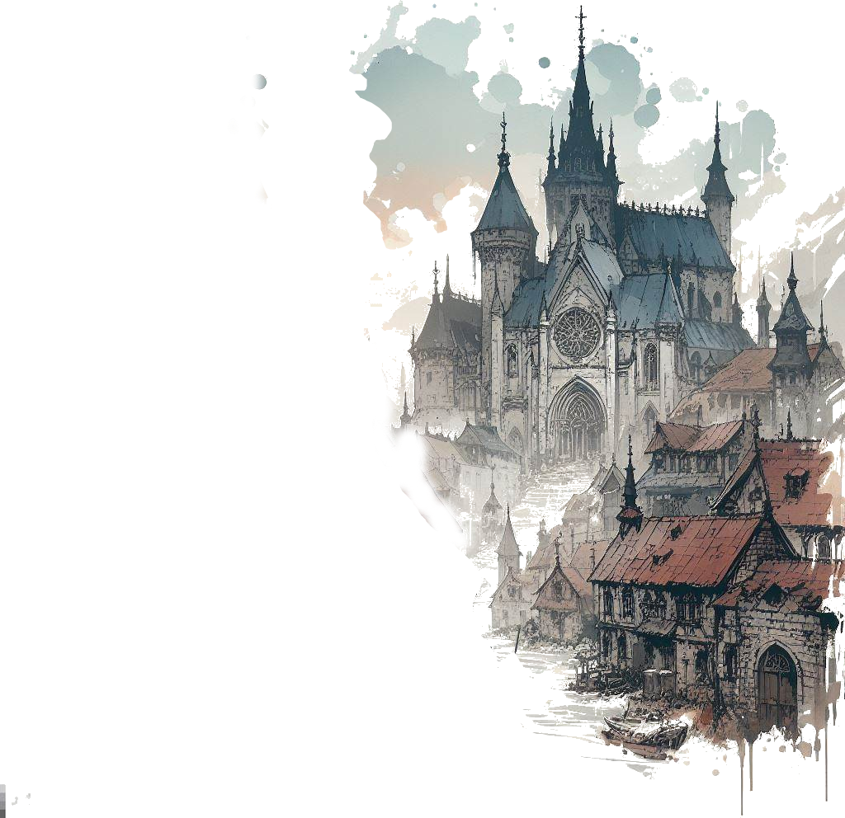*where you will discover a tapestry of secrets*

*woven into the very fabric of this town’s history.*

*Are the townsfolk merely succumbing to*

*paranoia, or does a palpable darkness truly lurk*

*beneath the surface?*

*These secrets are for* ***you*** *to unravel.*

*You will be playing the roles of fresh adventurers*

*exploring the small town of Whispervale and its*

*surrounding woods, rivers and meadows.*

*You will battle wicked monsters, interact with*

*the inhabitants of the town and piece*

*together clues to solve the overarching mystery*

*of Whispervale.*

*So ready your sword, find your notes and your map*

*markers, plan out accordingly, and immerse*

*yourselves in the story of Whispervale.*

You can give the players the extra information that they will play Level 1 characters and the theme, while not horror, has a tent of dark fantasy. There are (hopefully) no elements that would make the players uncomfortable:

There is no depicted gore or disturbing visual imagery in the book, not shown, nor told. There are no disturbing visuals and no topics that would be considered “taboo” in the real society.

However, the story can be gloomy, have the characters make morally gray choices, and contain potentially unsettling monsters (such as undead or spiders) or unusually looking people.

On the upside, the story provides props: maps, letters, clues and pictures of many locations and characters.

## Player Backstories

Player backstories won’t really matter, unless you choose to improvise them into the story, though that can be difficult. Tell them to come up with adventurer characters. with simple backgrounds, that would accept to be paid to escort a priest to another town - Whispervale.

With their permission, you will give them an extra reason to go to Whispervale (in the **Road to Whispervale** Location).

## Story Explained

The following is information that players will piece together throughout the campaign:

A couple hundred years ago, Lord Sedrik was a noble living in a mansion in Whispervale. He wanted the love of a mage, Mortessa, who was secretly practicing black magic. Lord Sedrik found out about it. She claimed she could make both of them immortal. Lord Sedrik wanted no such thing - black magic was unnatural.

The black magic practices were creating deep conflict in their relationship, as well as Mortessa’s secret rituals and dubious morality.

Mortessa held her opinion: “I can show you! I will show you!” she said. She cast a spell on Lord Sedrik and turned him into an immortal vampire through 1000 curse marks on his body, living him devoid of any bodily sensation and feeling depersonalized, like an empty vessel. The ritual unfortunately used several members of Sedrik’s family and people living in the mansion as tribute, and they all died.

Sedrik was enraged at the sight of him having become an abomination and he attacked Mortessa and swore to hunt her to death.

She escaped and fled, never to be seen again.

Lord Sedrik now resides somewhere in his lair and wants to rid himself of the curses of vampirism and kill Mortessa in justice and revenge.

Mortessa is keeping up an aura of life-draining, perpetually draining life from all inhabitants of Whispervale to keep her immortal. However, this aura is also protecting the citizens from being affected by Lord Sedrik’s special device (and against all blood magic artifacts and spells).

She also knows Sedrik will eventually come after her, so she has been raising an army of undead to both protect herself, and try to kill him before he kills her.

Sedrik can remove his curses by transferring them one by one to other people, though most don’t survive the curse marks. After more than 200 years of study, he finally discovered there is a way to remove the curse en masse - he is creating a device to transfer curses to a large part of Whispervale’s population. The device doesn’t work due to Mortessa’s draining protecting the citizens.

Luckily, a cult has formed around Sedrik’s curse marks and he plans to use the cult to get to Mortessa and remove some of the curse marks. Sedrik has also learned to use his vampiric abilities to subjugate and mind-control Mortessa’s stray undead in his favor.

Both Mortessa and Sedrik are villains in this story and seek to fulfil their goals by any means necessary.

Neither Mortessa nor Sedrik knows where the other is hiding.

## Players’ Progression

Players start escorting Father Alan, a priest, to Whispervale when they get ambushed by black ghosts, inflicting players with 1 of the 1000 curses of Sedrik.

A Witch named Riven can cure their curse with a magical lamp they will need to retrieve for her.

Players will also investigate Sedrik’s old mansion, where a different monster now resides. They will meet Sedrik face-to-face and find clues about where Mortessa lives.

They will go after Mortessa and end her life draining, and finally, they will find Sedrik’s hiding place and deal with him.

Of course, this is not as straightforward as it seems - players will have to talk to NPC’s, survive fights with undead, solve puzzles and mysteries and make their way through.

Whispervale also contains a lot of side quests, which are completely optional but are all tied to the main mission. Players can do these side quests to reveal more of the story (or more sides of the story) and for extra items, experience and gold.



# E:\Work\GitHub\Call of Heroes Design\StarterAdventure\UI\Title Underline.pngTitle UnderlineSpecial Rules

## Night Regeneration

After combat at night, Player Characters with the Curse Mark regenerate an extra +3 Health.

## Mortessa’s Aura

While Mortessa is alive, special Whispervale blood spells don’t work on Units that are not affected by the Curse Mark (players will find such spells later).

Whenever a player tries to use a blood magic artifact or spell on someone without a Curse Mark, tell them it simply fizzles out and nothing happens, as if the target is being blocked by something.

## Witch Doctor Special Rules

Since the Witch Doctor (Shaman) specialization uses blood magic, their powers won’t work unless they have the Curse Mark, until Mortessa dies.

If the players want to remove the Curse Mark later on, make sure you hint to the Witch Doctor player that their powers will fail from then on.

## Death

If one player dies, a citizen can replace them, having the same Level and they can play as them. Choose one from:

- Father Alan (Cleric, has an awakening as a Cleric)

- Periwinkle the Merchant (Mage, starts with 941 gold)

- Boris the Blacksmith (Warrior, has Missing Leg Feat)

- Sylvaine the Bard (Rogue)

You can find more details about these characters in the appendix.

## Party Wipe

If the whole party is wiped in a combat and they have the **Felinar of Passing**, the Felinar explodes and they are transported to the church basement in town. They lose the **Felinar of Passing**.

If they don’t have it, the game is over.

While some encounters are more difficult, none are meant to kill the players. Feel free to otherwise improvise a way to let players survive.

# E:\Work\GitHub\Call of Heroes Design\StarterAdventure\UI\Title Underline.pngTitle UnderlineRandom Encounters

## Angry Peasants

**Type**: Combat / Roleplay

**Recommended Party Level**: 1

Players are attacked by a group of angry peasants set on witch-hunting people with curse marks or who use black magic.

## Forest Smoke

**Type**: Exploration + Roleplay

**Recommended Party Level**: 1 (or any)

Players see smoke coming from the forest. Upon investigating, they find an injured villager studying blood magic.

## Ruins of Old Temple

**Type**: Combat + Puzzle

**Recommended Party Level**: 1

The ruins of an old small temple, now used by goblins as shelter. A runes puzzle reveals treasure and lore.

## Convoy of Undead

**Type**: Combat / Stealth

**Recommended Party Level**: 2

Players stumble upon a convoy of zombies and a carriage being pulled somewhere unknown, through the forest.

## Dragon in the Sky

**Type**: Exploration

**Recommended Party Level**: 2

Players witness a black dragon flying through the skies.

## Mysterious Cultists

**Type**: Combat / Roleplay

**Recommended Party Level**: 2

Players are approached by mysterious cultists that want to bargain (or fight) for players’ artifacts. They can provide lore or trade

## Town Vampire Hunt

**Type**: Combat + Roleplay

**Recommended Party Level**: 2

In town, players witness a group of villagers set on finding a vampire hiding in town.

# E:\Work\GitHub\Call of Heroes Design\StarterAdventure\UI\Title Underline.pngTitle UnderlineBefore Starting…

Before starting, some players get private information. They are free to keep the information a secret or reveal it whenever they like.

## If there is a **Druid** player…

*You’ve heard rumors of a certain druid living on*

*the outskirts of Whispervale, isolated from*

*society. Word goes around that this druid,* ***Riven****,*

*can cure both poisons, minor illnesses and even*

*more potent curses.*

*Naturally, you felt inclined to find out more, and*

*perhaps Riven could teach you a thing or two!*

*Feel free to share the information with the others*

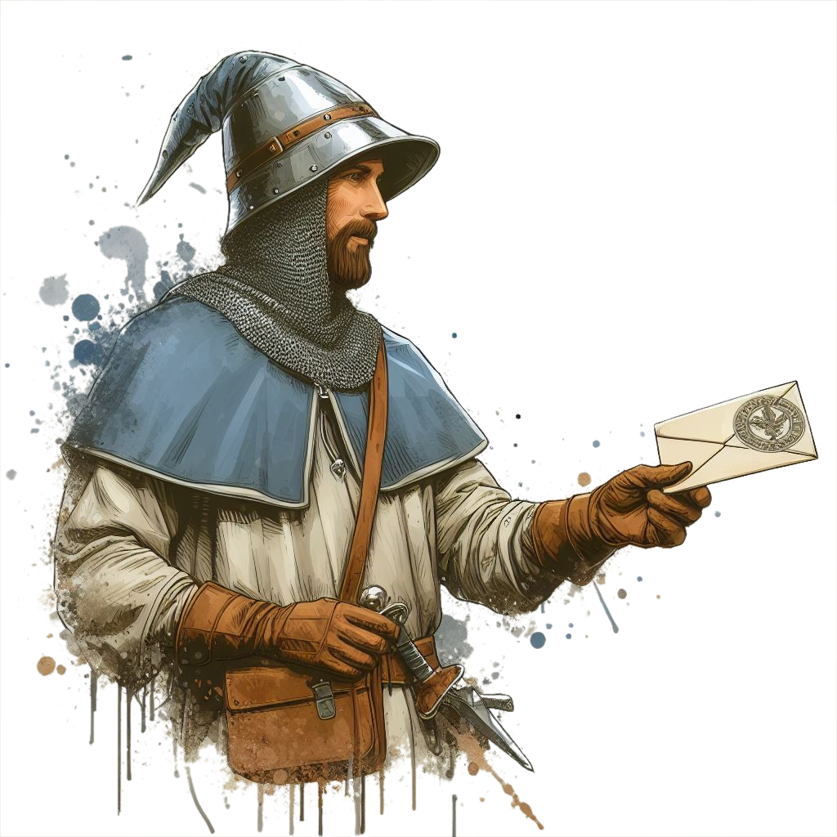*when you see fit, or keep it secret.*

## Gradient TopIf there is a **Rogue** player…

*You will be paid to escort a priest to a town called*

*Whispervale, together with the other adventurers.*

*However, you secretly have another reason to visit*

*Whispervale…*

*Your sources say there is an* ***abandoned mansion***

***full of riches*** *near Whispervale. Old rich folk hide*

*their treasures in armchair stuffing and under*

*fake cabinet bottoms - piece of cake, you know*

*where to look! Grab it while they’re not looking!*

## If there is a **Shaman** player…

*You will be paid to escort a priest to a town called*

*Whispervale, together with the other adventurers.*

*However, you secretly have an extra reason to visit*

*Whispervale…*

*You sense breaches in reality that connect the*

*mortal realm to a parallel spirit dimension called*

*the* ***Shadowrealm****… as if someone is using the*

*Shadowrealm to go in and out, and appear at*

*different locations.*

*Naturally, you felt inclined to investigate.*

*Feel free to share the information with the others*

*when you see fit, or keep it secret.*

## If there is a **Warlock** player…

*You will be paid to escort a priest to a town called*

*Whispervale, together with the other adventurers.*

*However, you secretly have an extra reason to visit*

*Whispervale…*

*You’ve heard of a certain magical*

*artifact called the* ***Felinar of***

***Passage****. This item would allow*

*the user to create passages*

*through a different realm and quickly travel*

*between locations. A fitting power for your*

*ilk!*

*Feel free to share the information with the others*

*when you see fit, or keep it secret.*

# Gradient TopGradient Top

# E:\Work\GitHub\Call of Heroes Design\StarterAdventure\UI\Title Underline.pngTitle UnderlineRoad to Whispervale



*Not long ago, you arrived at Outwell, a small town*

*huddled on the outskirts of the realm, marking your*

*final stop before setting off to* ***Whispervale****, your*

*next destination.*

*The days of early autumn spent on the road have*

*so far been uneventful. As you linger at the edge of*

*the town, you await for your employer and new*

*travelling companion: a priest by the name of*

*Father Alan.*

*You have been tasked with protecting Father Alan*

*on the 2-day road to the town of Whispervale. You*

*picked up this job from a simple questboard. The*

*priest was promising to pay 100 gold per person*

*for seeing that he reaches Whispervale safe and*

*sound.*

## If there is a Paladin or Cleric player…

*Of course, to you [Paladin or Cleric], Father Alan is*

*no mere priest - in your religious studies, you’ve*

*come to know Father Alan personally. You’ve*

*taken part in his sermons and, to you, he has*

*become a trustworthy figure, one you can look up*

*to and ask for advice without inhibitions. That’s*

*why he has chosen you specifically for this mission,*

*and told you in person the day before to join the*

*others on the road. You will, of course, be paid, too.*

*Father Alan always keeps his word.*

*Father Alan is not well-versed in fighting, and while*

*he can do some magic, he is more of a teacher, or*

*a people’s person. He needs you on this journey.*



*As you keep your eyes peeled for the priest, a*

*figure emerges from around a nearby building.*

*He walks slowly on the cobblestone road towards*

*you, carrying nothing but a book and a small*

*satchel of road provisions.*

*He looks to be a human in his late 50’s, wearing a*

*thick brown-gray beard, and dressed in humble*

*priestly robes of white and brown.*

*He approaches cautiously, and, with a subtle smile*

*on his face, he raises his hand and greets you:*

## *Father Alan Johnson (Father Alan.png)*

Calm, religious and calculate in his words. Serious but can appreciate humor.

Feel free to show the players a *picture of Father Alan*.



*“Greetings! Apologies for the wait, I did not expect*

*you to be here early!*

*I am Father Alan, the man you will be escorting*

*to Whispervale. You look like capable folk, I hope*

*we will get to know each-other better on the*

*journey ahead!*

*How should I call you, by the way? Feel free to*

*introduce yourselves… to me and to your new*

*companions if you haven’t exchanged pleasantries*

*yet!”.*

Ask each player to introduce their character to you and to the other players - what is their name, class and personality?

When finished, continue to the next page to Father Alan’s dialogue lines.

## Continuing…

After the players introduce themselves, continue the narration.



*Having met your new teammates, you set off to*

*Whispervale. Unfortunately there are no carts or*

*carriages going to Whispervale for easier travel and*

*the journey will take a day and a half, at normal*

*pace. It is an isolated settlement down a forest path,*

*not part of the same realm as the towns you’ve*

*been to. Due to neglect, fear of road bandits, or*

*ignorance, not many people travel to Whispervale.*

*You tread along the forest road, leaves cracking*

*beneath your feet. The air is crisp and clear,*

*carrying the scent of moss and canopy trees. It is*

*still daylight, and you still have a few hours to go*

*before you need to camp for the night.*

## Father Alan Road Dialogue

Father Alan will engage in dialogue with the players while walking, to pass time. If they don’t engage,

feel free to directly say some of the **…** lines.



*“I haven’t told you why I am going to Whispervale*

*on such short notice. I received word the previous*

*priest of Whispervale went missing.”*

*“They looked for him for several days.”*

*“Nobody knows where he went… but we had to find*

*someone to replace him… I fear something may*

*have happened to him. I didn’t know him*

*personally but… I need to investigate.”*

*...I’ve been to* ***Whispervale*** *before. It’s a nice, quiet*

*town. Haven’t been there in years, though.*

*...****Dangers****? Mostly bandits and goblins. They stalk*

*these roads. No wonder people are afraid to travel*

*to Whispervale.*

*…****Townsfolk****? I just visited the church… [shrugs]*

*…****Map****? I don’t have a map of the area, but I have a*

*map of Whispervale! Here… [give the players the*

*Whispervale Town Map]*

*…****Religion****? We preach the gospel and praise the*

*one true god, of course. [feel free to improvise*

*more, it won’t be very important]*

*…****Powers****? Oh, magic is not part of my training. I can*

*do some basic rituals, but not much else. I am more*

*of a people’s person, and a teacher.*



*...****Fighting****? No, I don’t fight. Though I pray no one*

*will give us any trouble on the road ahead. If they*

*do, I hope we can solve it peacefully.*

## Continuing…

After Father Alan is done conversing with players…



*By now, you’ve traveled for quite some time and*

*it is getting darker, as the autumn days grow*

*shorter.*

*“We still have a good hour of light before we*

*should camp for the night. Does any of you know*

*how to make a fire?” asks Father Alan.*

*[Speaking as the GM] I would everyone to make*

*an Intelligence Check: roll a 12-sided die and add*

*your Character’s Intelligence Stat number to the*

*result.*

Everyone who got at least a 5 knows how to make a fire.



*Father Alan gives a nod of approval.*

*“Great!” he says. “It will keep us warm through the*

*night. I know an alcove nearby where we can*

*safely camp. We can setup our tent there and…”*

*Father Alan pauses for a moment, looking from side*

*to side.*

*“Something feels wrong… do you feel that?”*

*The players will soon be ambushed by Whispershades - undead ghosts.*

Ask the player(s) with the highest Sense to make a Sense Check.

If any gets at least 8, tell them this:



*You feel an odd chill in the air, and a slight shiver*

*down your spine. The surroundings are strangely*

*quiet… no sound coming from the woods.*

If not:



*You struggle to understand what Father Alan is*

*sensing, but surely he senses* ***something is wrong****.*

Wait for the players to react.

Whatever they do or say, continue without letting too much time pass:



*As you are [doing/saying], a smoky shadow*

*materializes, growing and morphing into a bizarre*

*creature - a black phantom with razor-sharp claws,*

*mere meters away!*

*You soon notice several more such creatures*

*appearing around your group out of thin air!*

*Emitting an eerie shriek as it hovers just above the*

*ground, the apparition flies towards you with*

*menacing intent, claws poised to strike! [show*

*the players a picture of a Whispershade]*

*[As GM] Everyone roll for Initiative!*

*Roll a 12-sided die and add the Initiative number*

*from your character sheet.*

*You will now begin combat, and the numbers you*

*roll will determine the order in which you take turns.*

Write down the number of each player in descending order, and the number of the number 7 in there too.

All Whispershades have an initiative of 7 and don’t roll.









# Title Gradient 6Introduction

Use this template for homebrew. It is similar to what the final version of the book will look like.

You’re free to edit and adjust it to your liking.

You have all the specifications in the README file.

The font used is LinuxLibertine (you will have to install it on your computer).

Select this text together with the chapter section, copy it and paste it.

The underline should be 5 pixels below the ‘p’ immediately after the graphic goes below the chapter section.

The Chapter Section should always be on the left.

Always use copy paste for these elements to preserve the format.

## Subsection

This is a subsection. No special rules.

## Background & Details

After you’re done with a page, you can copy and paste the gradient from the top and bottom of the page.

## Title Text

For a main title (like QuestGuard), use the PSD template on <https://photopea.com> (or Photoshop) to create your title. Create a new text based on the specifications with the text tool, then overlay letters one by one over your font letters. Then delete the text and keep only the overlapped letters.

Oh yeah, and you need to load the Eczar font into Photoshop.

## Readme

For the specifications of the font, document, etc, see the README file.

Chapter Section

This is an alternative look for the Chapter Section.

## Supsection

This is another example of a subsection with some normal text, and following it is an aside box.

You can use this for **read-aloud text**.

*Here we have a nice little aside box. Use*

*Calibri* ***Italics 10.5px*** *when working with this.*

*By the way [this is not meant to be read aloud].*

*Also, leave 1 space of indentation to the left.*

*And make sure there is enough space on the right.*

*This text is just a continuation of the text*

*above, in a different font.*

Feel free to resize the aside box background as you see fit. Also, here is a list, also Calibri I. 10.5px:

* *Small lamp*
* *25 gold in leatherworking materials*
* *Shortsword*

That was a list. Use copy/paste to paste the list.

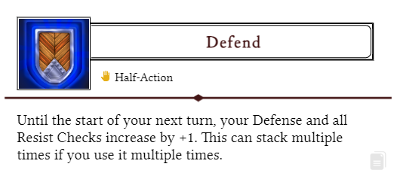

That was an Ability from the website (using the copy/paste button from the Ability box).

## Artwork

This text works

great with the goblin

on the right side of the

screen and the artwork

fits well. Lorem ipsum

dolor sit amet tristique

delirium sumus but take

into consideration that

the text should be

just long enough to fit here

nicely. The easiest way to

add artwork like this is to just

set its box to “behind text” and

you will be able to move

it around without doing

anything wicked to the

text, and gives you full control of

how you position your text. Use

spaces and enter with courage,

lads!

## Tables

Copy and paste this table when you want to create one. Pretty simple.

|  |  |  |
| --- | --- | --- |
| **Dice Roll** | **Description** | **Effect** |
| 1 | Stun | Target skips its next turn |
| 2 | Slow | Target has -2 Movements |
| 3 | Charm | Still not sure to this day |
| 4 | Exhausted | Half movement & actions |
| 5 | Fumbling | -2 to all rolls |
| 6 | Dazed | Halved actions, sir! |

That was a table. The background gradient is just an image, good luck moving it. If your table is on the left, you might want to flip the gradient for the rows.

